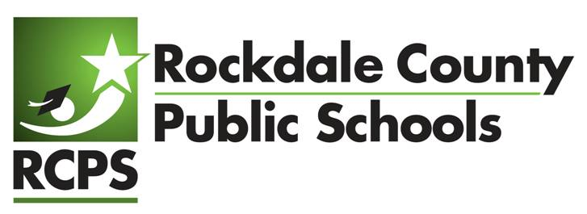

Superintendent’s Scholarship

The $1,000 Superintendent’s Scholarship will be awarded to a qualifying Rockdale County senior from one RCPS high school who has demonstrated their commitment to achievement and who intends to continue their education at a college or technical school after graduation. With the generous support of the RCPS Foundation the Superintendent will offer this scholarship and announce the recipient the week of May 13, 2024.

To apply, a student must:
- be a 2024 graduate in a Rockdale County public school,
- have been admitted to a college or technical school for the 2023-24 school year,
- not have received over $2500 in scholarships from other sources, and
- complete an application, including the essay portion.

APPLICATION:
Essay: (500 words max.) Describe how Rockdale County Public Schools (RCPS) has prepared you for the college you will be attending. What do you think RCPS can do to better prepare all students for their future?
Please return this form along with your essay to cball@rockdale.k12.ga.us no later than Friday, April 26, 2024 to be considered for this scholarship.

Last Name ___________________________ First Name _________________________MI_____
Address ______________________________________________________________________
City ___________________________ State ___________ Zip ______________
Home Phone: ______________________________ Email: _________________________________
Cell Phone: _____________________________________
High School: ________________________________________
I have been accepted to and will be attending

(name of college or technical school)
for the 2024-25 school year and have not received more than $2,500 in scholarships from other sources.

